



Lab-1

Powered by
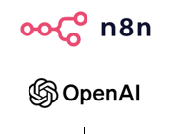

Learning Objectives
This lab will help you understand and apply a practical AI-enabled automation approach using n8n for banking transaction-risk review. You will learn how input files are collected, extracted, prepared, and combined before configuring a specialist AI Agent to perform a Customer Profile Risk Assessment using business rules and structured AI outputs.

By the end of this lab, students will be able to:

- Understand the n8n workflow automation environment and basic workflow structure.
- Configure a file upload form to collect customer, transaction, and rule files.
- Extract structured data from uploaded CSV files.
- Merge and pre-process customer profile and transaction data using a common Customer ID.
- Prepare and aggregate dynamic business rules for AI processing.
- Explain the role of LLM, User Prompt, System Message, and AI Agent.
- Configure Agent-1 – Customer Profile Risk Assessment.
- Apply AI guardrails to control how the Agent evaluates customer data and business rules.
- Configure Structured Output to produce consistent risk-assessment results.
- Generate the Customer Profile Risk assessment output for further processing in subsequent labs.

Task | Data Preparation & Customer Profile Risk Agent
1 | Configure the Agent-1 file upload form
2 | Extract the required CSV data
3 | Merge and pre-process customer, transaction, and rule data
4 | Configure Agent-1 – Customer Profile Risk Assessment

Business scenario
DXS Bank is a growing digital bank providing retail and business banking services, including transfers, cash deposits, digital payments, and remittances. As transaction volumes increase, the bank is receiving more alerts for potentially suspicious activity.

Analysts currently review customer KYC information, transaction history, and regulatory screening data from multiple sources. This process is time-consuming, repetitive, and difficult to scale, resulting in slower reviews, inconsistent risk assessments, and limited management visibility.

DXS Bank has engaged your group as FinTech Consultants specializing in AI Automation to design and demonstrate an n8n-based Agentic AI solution that improves the efficiency, consistency, and transparency of the transaction-risk review process while maintaining appropriate human oversight.

Business Requirements
DXS Bank requires the proposed solution to:

- Collect and process customer profile, transaction, cash deposit, and regulatory screening data together with configurable risk rules.
- Use specialist AI Agents to perform Customer Profile Risk, Transaction Pattern Risk, and Regulatory Screening Risk assessments in parallel.
- Use an Agentic AI Orchestrator to combine the specialist findings into an overall customer risk assessment.
- Produce an overall risk level, risk score, key risk indicators, and recommended action.
- Generate consolidated customer risk output and executive dashboard for management visibility.
- Ensure that higher-risk cases remain subject to human review and final decision-making.

Agentic AI Risk Assessment Orchestration
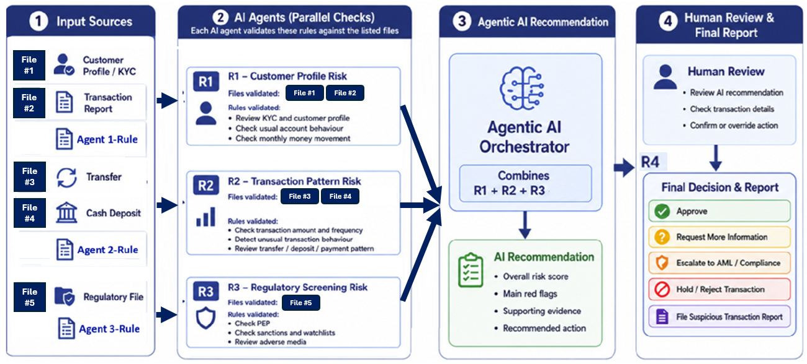

Agentic AI n8n workflow orchestration
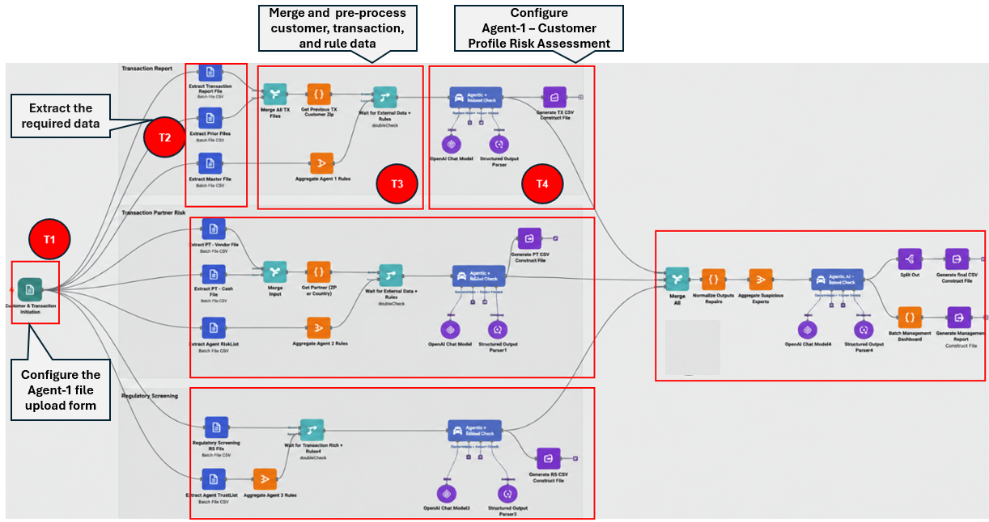

Task 1 | Configure the Agent-1 File Upload Form

The Form Trigger is the starting node of this workflow. It creates a simple web form that allows students to upload the CSV files required for the risk assessment. When the form is submitted, n8n starts a new workflow execution and passes the uploaded files to the next nodes for extraction and processing. In this section, we will first configure the F1 Customer Profile file upload. The same pattern can later be repeated for the other required files.
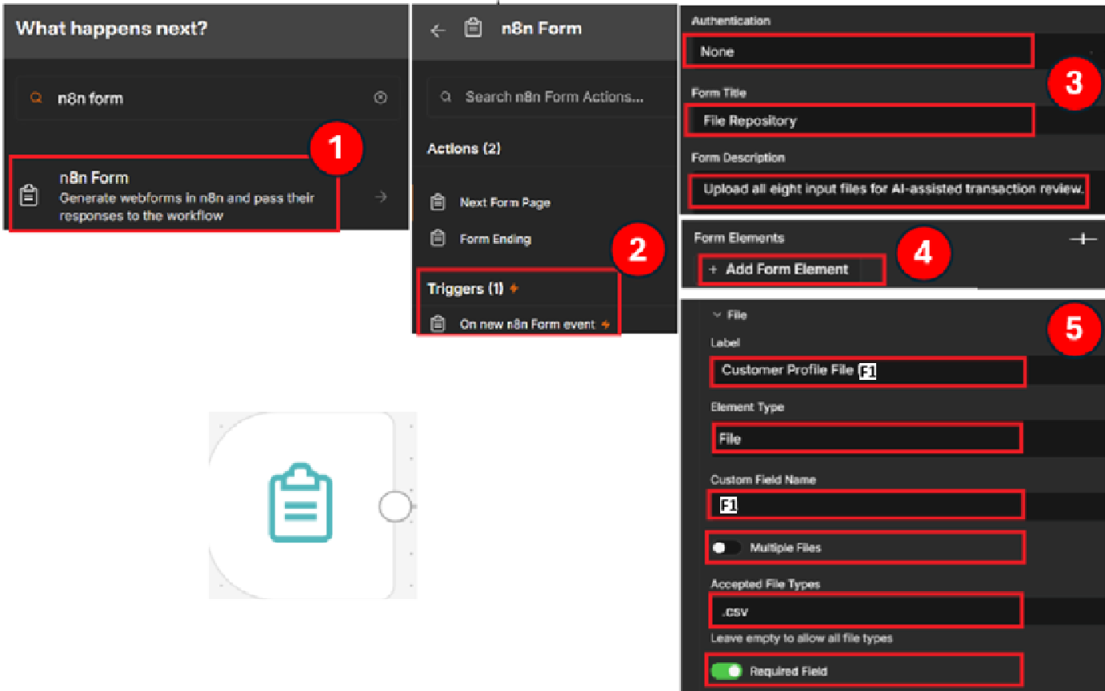
Step 1 - Add the Form node
Start by adding the node that will launch the workflow.
Click the "+" button on the n8n canvas to add a new node. In the search box, type "n8n Form", then select "n8n Form" from the results. Label the node as “Customer & Transaction Validation”

Step 2 - Choose the Form Trigger
Next, tell n8n what should trigger the workflow.
Under "Triggers", select "On new n8n Form event". This creates the Form Trigger node and makes it the starting point of the workflow.

Step 3 - Configure the form details
Now give the form a clear title and description so students know what they are uploading.
Open the Form Trigger node and configure:

Authentication = None
Form Title = File Repository
Form Description = Upload all eight input files for AI-assisted transaction review.

Step 4 - Add a file upload field
With the form created, scroll down to the Form Elements section.
Scroll to "Form Elements" and click "+ Add Form Element". This adds a new input field to the form.

Step 5 - Configure the F1 upload field
Use the new form field for the F1 Customer Profile CSV.
Set the values as shown.

Label = Customer Profile File F1
Element Type = File; Custom Field Name = F1
Multiple Files = OFF (Click Add Attributes)
Accepted File Types = .csv (Click Add Attributes)
Required Field = ON (Click Add Attributes)

Step 6 - Add the Remaining Upload Fields
Once the F1 upload field is configured, repeat Step 4 and Step 5 to add the remaining required files, one by one, shown in the table below to the same Form Trigger.

No | File to Add | Suggested Label | Custom Field Name | Element Type | Required
1 | Customer Profile File F1 | Customer Profile File F1 | F1 | File | Yes
2 | Transaction Report File F2 | Transaction Report File F2 | F2 | File | Yes
3 | Agent-1 Rules | Agent-1 Rules | Agent_1_Rules | File | Yes

Task 1- Expected Output

Task 1 is complete when the Customer & Transaction Validation Form Trigger is configured with the F1 Customer Profile, F2 Transaction Report, and Agent-1 Rules upload fields for the Agent-1 workflow.
.
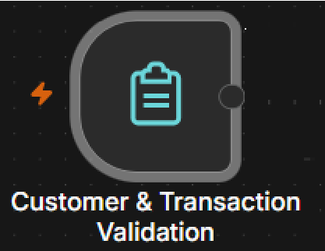

Task 2 | Extract from File Node

The Extract from File (Choose from CSV) node is used to read the contents of an uploaded file and convert it into structured data that n8n can process. Each uploaded file is stored under its Custom Field Name from the Form Trigger. The Extract from File node must use that exact same name in the Input Binary Field.

For Example: Form Trigger
Custom Field Name = F1
↓
Extract from File
Input Binary Field = F1
↓
Structured transaction data

This allows the customer and transaction records inside the CSV file to be used by the Merge, Code, and AI Agent nodes later in the workflow.

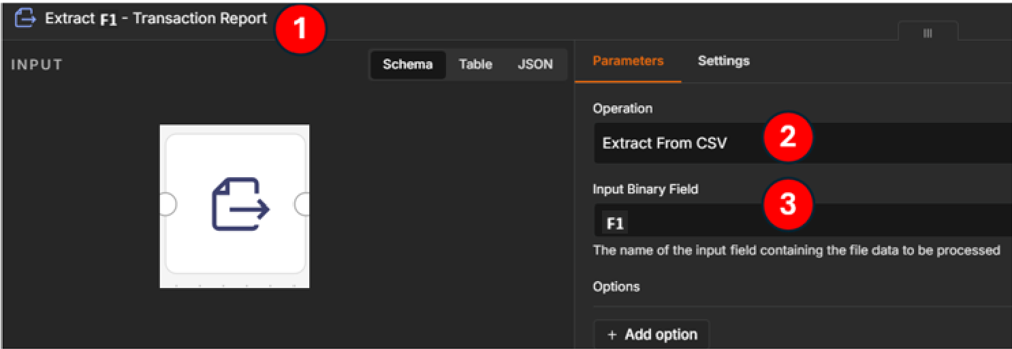
Step 1 - Add the Extract from File node
After adding an Extract from File node, rename it so that its purpose is easy to identify on the workflow canvas.
For the F1 Transaction Report, use: Extract F1 – Customer Profile

Step 2 - Select the CSV extraction operation
Open the node and go to the Parameters tab.
Under Operation, select: Extract From CSV

Step 3 - Specify the uploaded file
In Input Binary Field, enter: F1

Step 4 – Repeat the Extract configuration for the remaining files
Once the F1 Extract from File node is configured, repeat Steps 1, 2, and 3 to create the Extract nodes for F2 Transaction Report and Agent-1 Rules.

No | File | Extract Node Name | Input Binary Field
1 | Customer Profile File F1 | Extract F1 - Customer Profile | F1
2 | Transaction Report File F2 | Extract F2 - Transaction Report | F2
3 | Agent-1 Rules | Extract Agent Rules | Agent_1_Rules

Task 2- Expected Output
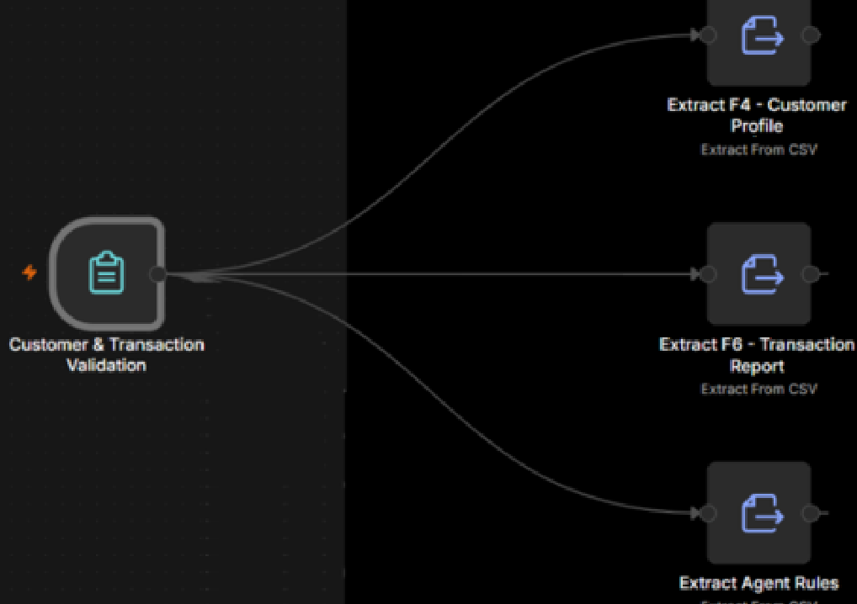
To connect the nodes on the canvas, click and hold the output connector on the right side of the Customer & Transaction Validation Form Trigger, then drag the connection line to the input connector on the left side of each Extract node.

After configuring the three Extract from File nodes for the Agent-1 branch, your workflow should look like this:

Task 3 | Merge the F1 Customer Profile and F2 Transaction Report Data

In this task, you will combine the extracted F1 and F2 data streams and prepare them for customer-level matching using Customer_ID.

The Merge node first brings the records from both input branches into one combined stream. At this stage, the records are only appended together; they are not yet matched customer by customer.

In the next step, a Code node will use Customer_ID to join the corresponding F1 and F2 records so that each customer has one complete record for Agent-1.
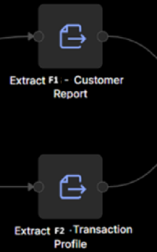
Step 1: Add and Rename the Merge node

Add a Merge node to the workflow canvas.

Place it after the two Extract nodes:
Extract F1 - Customer Profile
Extract F2 - Transaction Report
Rename the Merge node to: Merge F1 & F2

Step 2: Set the Merge Mode

Open the Merge node and go to the Parameters tab.
- Under Mode, select: Append (Append places the F1 records and F2 records into one combined stream without changing the data).

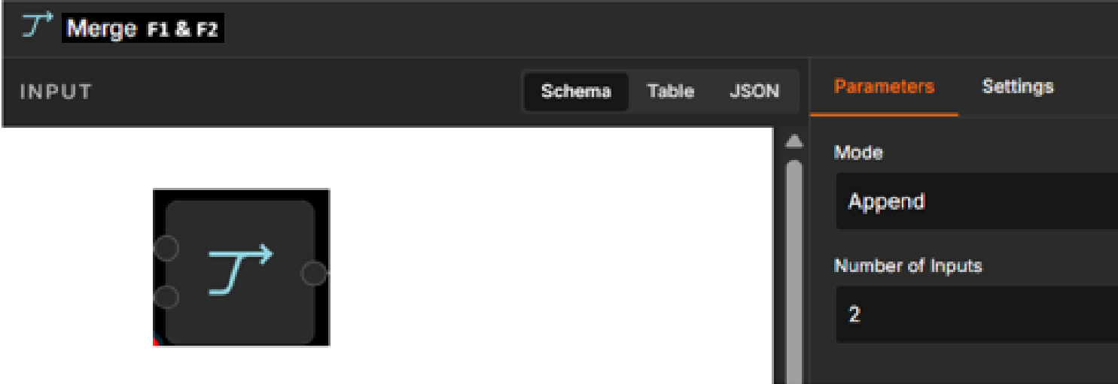
- Under Number of Inputs, enter: 2
Two inputs are required because the Merge node receives data from:

Input 1 → Extract F1 - Customer Profile
Input 2 → Extract F2 - Transaction Report

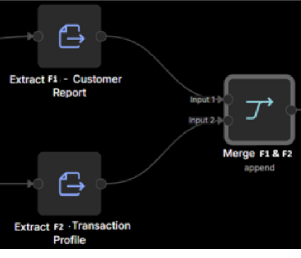
Step 3: Connect the Extract nodes to the Merge node
- Drag a connection from the output of:
- Extract F1 - Customer Profile to Input 2 of Merge F1 & F2.

- Drag a connection from the output of:
Extract F2 - Transaction Report to Input 1 of Merge F1 & F2

Step 4: Add and Configure the Code Node
After completing the Merge F1 & F2 node, add a Code node to combine the F1 Customer Profile and F2 Transaction Report records using Customer_ID.
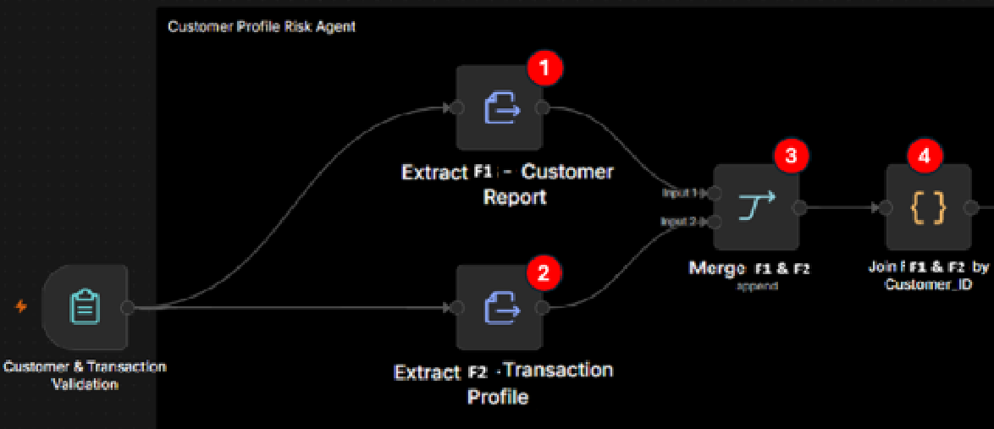
Open the node and configure:
- Mode: Run Once for All Items
- Language: JavaScript
- Then paste the following code into the JavaScript editor:

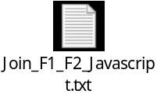

At this point, the Code node joins the matching F1 and F2 records by Customer_ID and produces one combined customer record for Agent-1.

Step 5: Add and Configure the Aggregate Node for Agent-1 Rules

After extracting the Agent-1 rules from the CSV file, add an Aggregate node so that all rule rows are collected before they are passed to Agent-1. Rename the new node to Aggregate Agent-1-Rules

Open the node and configure the fields as shown in the image.
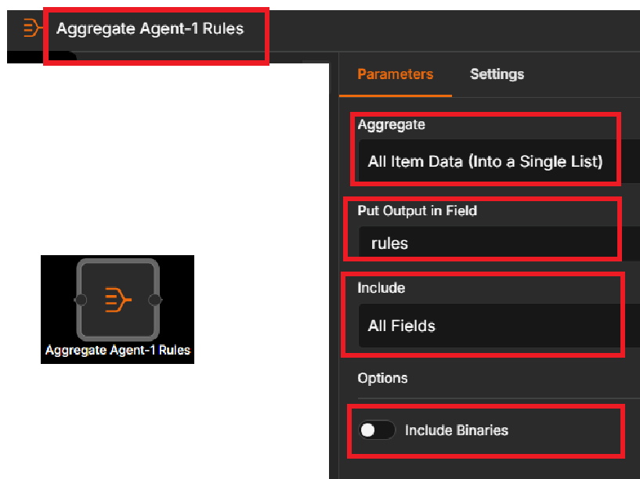
- Node Name: Aggregate Agent-1 Rules
- Aggregate: All Item Data (Into a Single List)
- Put Output in Field: rules
- Include: All Fields
- Include Binaries: OFF

Step 6: Add and Configure the Wait Node for Customer Data and Rules

After preparing the joined customer data and the aggregated Agent-1 rules, add a Merge node to make sure both branches are ready before the workflow continues to Agent-1.

Connect the branches as follows:
Join F1 and F2 by Customer_ID → Input 1
Aggregate Agent-1 Rules → Input 2
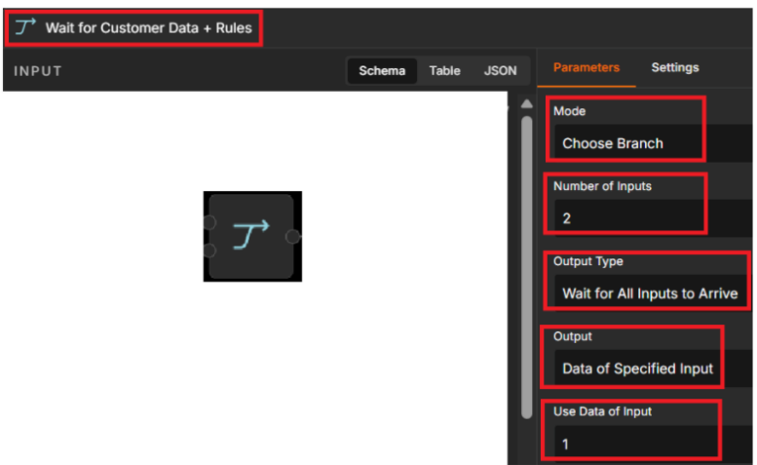

- Rename the node to:
- Wait for Customer Data + Rules
- Mode: Choose Branch
- Number of Inputs: 2
- Output Type: Wait for All Inputs to Arrive
- Output: Data of Specified Input
- Use Data of Input: 1

Task 3 - Expected Output

Task 3 is complete when the F1 and F2 records are joined by Customer_ID, the Agent-1 rules are aggregated, and both branches connect to Wait for Customer Data + Rules.

After this step, the customer data is ready to be sent to Agent-1, while the rules are already available for the Agent-1 prompt to reference.

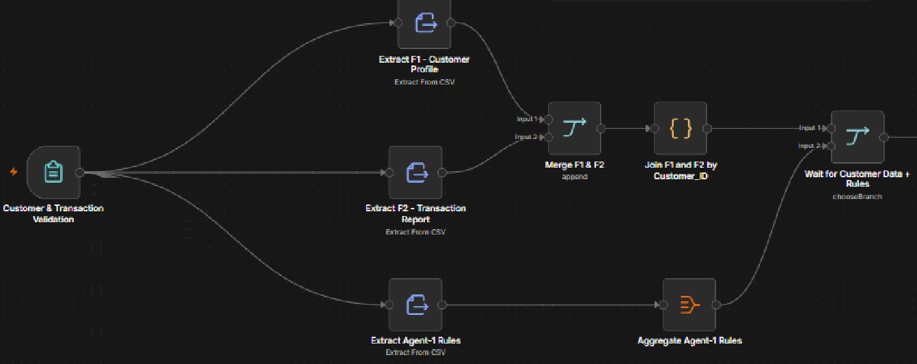

Task 4 | Configure Agent-1, the Chat Model, and the Structured Output Parser

In this task, you will configure Agent-1 to evaluate the customer profile risk using the current customer record and the uploaded Agent-1 rules. You will also connect the OpenAI Chat Model and the Structured Output Parser so that Agent-1 returns a consistent JSON result.

Step 1: Add and connect Agent-1, Chat Model, and Output Parser
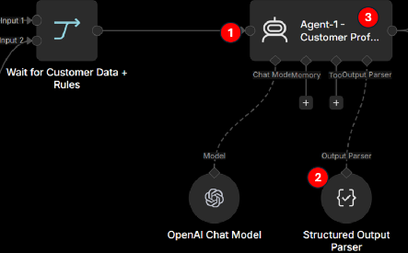
- Add an AI Agent node after: Wait for Customer Data + Rules
Rename to : Agent-1 - Customer Profile Risk

- Then connect: An OpenAI Chat Model to the Chat Model connector a Structured Output Parser to the Output Parser connector as shown.

Step 2: Configure the Structured Output Parser
- Open the Structured Output Parser node.
Set: Schema Type: Generate From JSON Example

- Paste this JSON code into the JSON Example field:

{"Customer_ID":"CUST0001","Customer_Name":"Example Customer","Risk_Level":"HIGH","Triggered_Rules":["A1-R02"],"Supporting_Evidence":["Total_Monthly_Transaction_Value exceeded the rule threshold"],"Summary":"Customer matched at least one Agent-1 rule.","Recommended_Action":"MANUAL_REVIEW"}

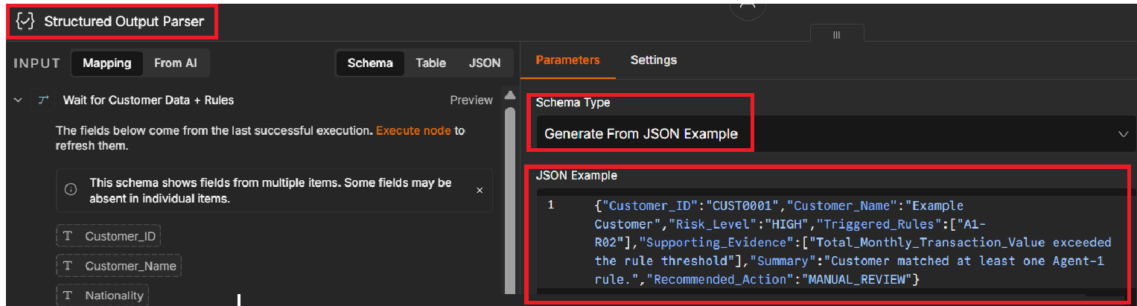

Step 3: Configure the Agent-1 User Prompt
- Open the Agent-1 - Customer Profile Risk node
Set Source for Prompt (User Message): Define below

- In Prompt (User Message), enter:

Customer record:  {{ JSON.stringify($json) }}  Agent-1 rules:  {{ JSON.stringify($('Extract Agent Rules').all().map(item => item.json)) }}  Evaluate this customer against every supplied rule. | This gives Agent-1 both:  - current customer record  - complete Agent-1 rules list

- Turn on: Require Specific Output Format to inform Agent-1 to follow the structure defined by the connected Structured Output Parser. Make sure the parser is connected to the Output Parser port under Agent-1.

Step 4: Configure the Agent-1 System Message
- Scroll to Options → System Message and enter the Agent-1 instructions.
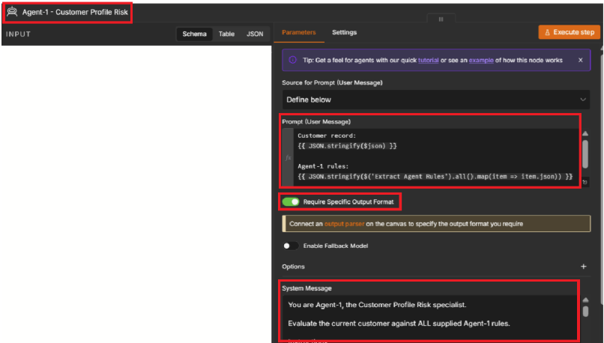
- Use the provided
system message script.

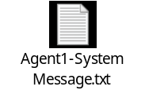

Step 5: Configure the OpenAI Chat Model
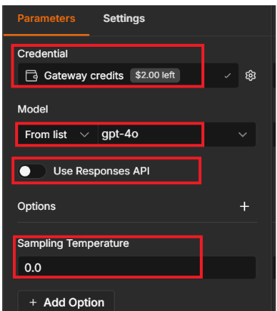
- Open the OpenAI Chat Model node connected to Agent-1.

- Under Credential, set the credentials as shown.

Set
- Credential: Gateway credit ($2.00)
- Model: gpt-4o-mini
- Use Responses API OFF
- Click on Add Option and set the Sampling Temperature to 0.0

This ensures the AI Agent uses the selected OpenAI model with deterministic behavior for rule evaluation.

Step 6: Connect Agent-1 to Generate R1 CSV

After Agent-1 produces the structured customer risk result, add a Convert to File node and rename it Generate R1 CSV. Then connect it directly to the main output of Agent-1 - Customer Profile Risk.

Configure the node to:
- Operation: Convert to CSV
- Use the file name:R1_Customer_Profile_Risk.csv
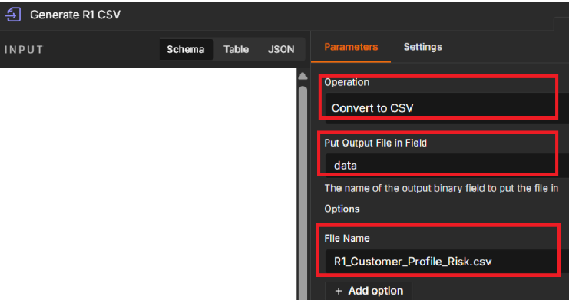
The final connection should be:
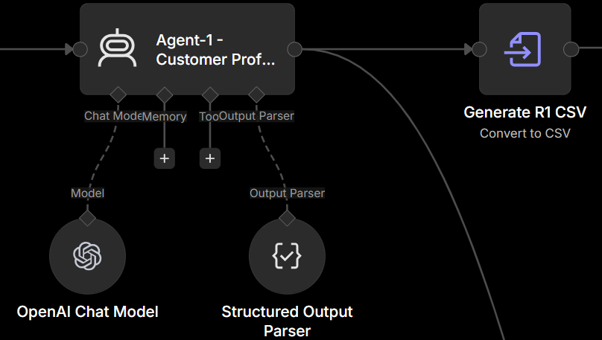

Step 7: Test the workflow
- Click the  button at the bottom of the screen to run and test the complete workflow.

Note: Groups are encouraged to test Labs 1, 2, and 3 using the same Dataset 0. This will help speed up workflow testing and reduce token consumption. Once the workflow produces the expected output using Dataset 0, use Dataset 1 and Dataset 2 to run the final tests and update the Answer Document with the required results.

Task 4 - Expected Output

Task 4 is complete when Agent-1 is fully connected to the OpenAI Chat Model and Structured Output Parser, receives the prepared customer data and rules, and generates the R1 Customer Profile Risk CSV.

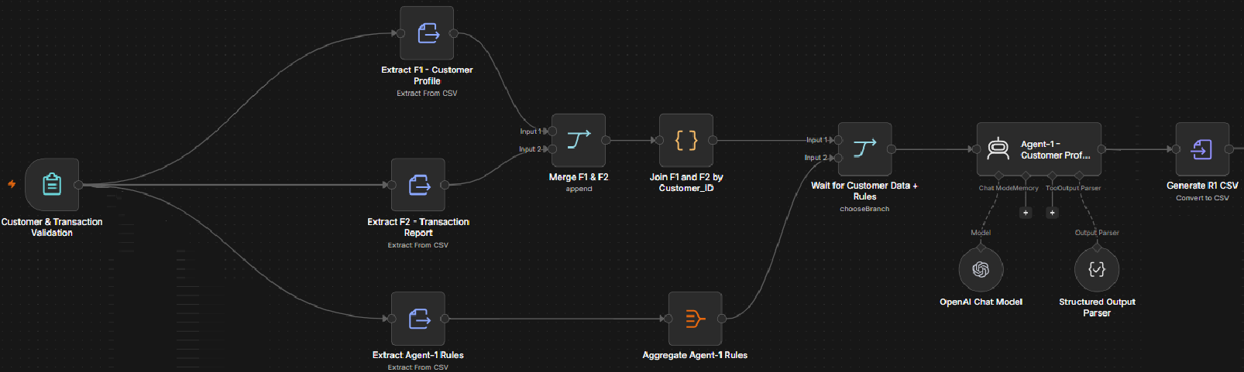



Please update your Answer document

Thank You

